
Instructor: Jeanie C. Crain, PhD
Office Location: 212 C Eder Hall
Telephone: Office – 816-271-4322
Skype: jeanie124
E-mail: mailto:crain@missouriwestern.edu
Office Hours: TR 12:30-2:30, by Appointment
Course Identification
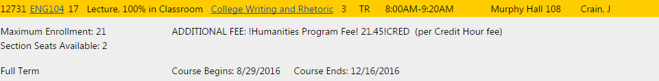
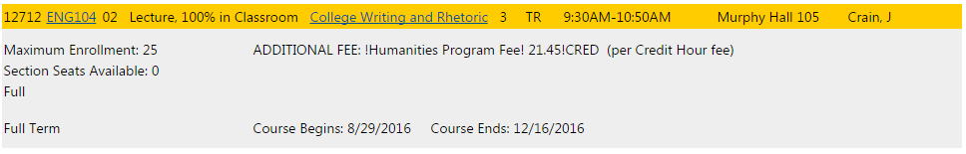
Description: Offered: F, Sp, Su. Instruction in reading and writing; emphasizes expository prose. Fulfills first half of the general studies requirement in English composition. Prerequisite: A grade of C or higher in RDG 095, or an ACT Reading score of 18 or higher, or a passing score on the Accuplacer test. A grade of C or higher in ENG 100, or an ACT English score of 18 or higher, or a passing score on the Writing Placement Examination. (See class schedule for information about placement exams.)

General Information
This course emphasizes the following objectives:
College Writing
- Active, analytical reading and critical writing
- Practicing writing in various forms (examples include: academic essay, email, speech, website, blog, video, digital communication)
- Engaging in close reading of texts (being able to read a text and comment on it analytically or rhetorically, e.g. audience, context, purpose)
- Practicing critical thinking and critical writing activities, e.g. critical response journals, academic essays, blogs, peer responses
- Locating, evaluating, and using scholarly sources within academic prose; Engaging in research-based argument (attribute, document, and incorporate others’ ideas in one’s own text)
- Practicing organizational methods in writing
- Learning Written Standard American English conventions (spelling, grammar, editing, use of a style manual, MLA style)
- Learning and practicing a variety of processes including invention, drafting, and revision strategies (multiple drafts reviewed with feedback by peers and/or instructor)
Rhetorical Awareness
- Writing for various contexts, purposes, and audiences (rhetorical writing)
- Attention to audience awareness and the use of language or graphics to appeal to specific audiences (the various tools of persuasion)
- Understanding and use of rhetorical terms such as rhetoric, ethos, pathos, logos and kairos
- Understanding how context affects the construction of a text; creating texts with attention to context
- Practicing style in order to enhance communication

Specific Requirements
Complete four carefully crafted essays (3-5 pages double-spaced. Times New Roman, MLA format) firmly grounded in assigned readings (15 points each). Additional points (40) will be determined relative to required pre-writings (2 for each essay) worth up to 5 points for each). All work (prewriting and paper) will be completed and submitted in Moodle (before class session) as well as hard copy.

Required Texts
- 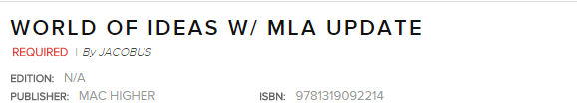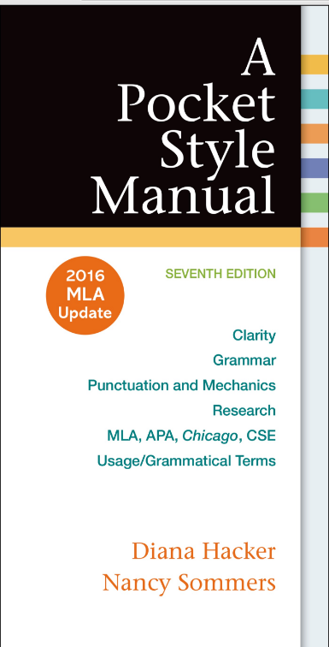 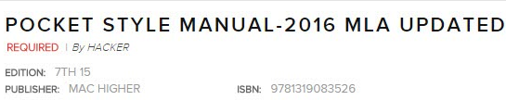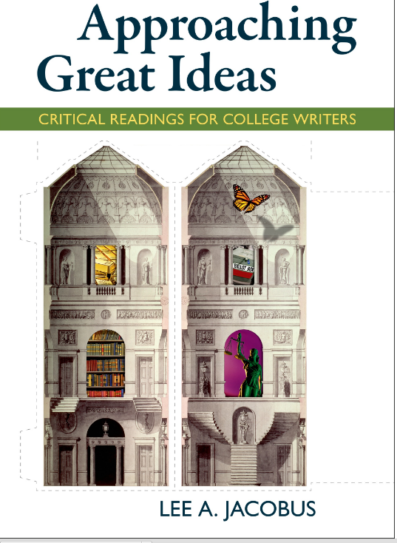 Bookstore ordered 9th edition.

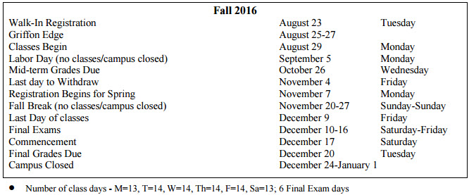

Course Schedule
 | Topic |  | Points
Week 1
August 30, 31 | Orientation | Group Assignments
 |  | Review 1, 2  Handbook: MLA 29, 30, 31,32 | Examining, writing about ideas, establishing arguments
 | Please note: read and work ahead of assignments.
Week 2 | Topic |  | Points
Sept. 6, 8 | Science and Nature, “Discoveries of the Mind,” 8
 | Everyone reads 5 articles; each member answers questions on page 18 for 1 article (choose in group); share responses in class on Sept. 6 (6 copies).  Handbook: 14 Repair sentence fragments  15 Revise run-on sentences. |  | 5
Week 3 | Topic |  | Points
Sept 13, 15 | Craft thesis statement in relation to one article (page 24-29) + Support and analysis statements in outline form (page 46). Submit 6 copies on Sept. 15.  17 The comma |  | 5
Week 4 | Topic | Reading | Exercises
Sept. 20, 22 | Essay 1 due at end of class on Sept. 22. |  | 15
You may use any article you wish, but you must acknowledge and submit work belonging to another group member.

18 The semicolon and the colon
Notes:
Week 5 | Topic |  | Points
Sept. 27, 29 | Ethics and Morality, 3 |  | 5
Everyone reads 5 articles; each member answers questions on page 18 for 1 article (choose in group); share responses in class on Sept. 27 (6 copies).

Handbook: 1, 2, 3 Clarity
Week 6 | Topic |  | Points
Oct. 4, 6 | Craft thesis statement in relation to one article (pages 24-29) + Support and analysis statements in outline form (page 46). Submit 6 copies on Oct. 4.  Handbook: 4, 5, 6 Clarity |  | 5
Week 7 | Topic |  | Points
Oct. 11, 13 | Essay 2 due Oct. 13 at end of class. |  | 15
You may use any article you wish, but you must acknowledge and submit work belonging to another group member.

Handbook: 7, 6, 9 Clarity
Week 8 | Topic | Reading | Exercises
Oct. 18, 20 Conferences
MT Grade due Oct. 26
Week 9 | Topic | Reading | Exercises
Oct. 25, 27 | Wealth and Poverty, 4
MT 26
 | Everyone reads 5 articles; each member answers questions on page 18 for 1 article (choose in group); share responses in class on Oct. 25 (6 copies).  Handbook: 10, 11, Grammar |  | 5
Week 10 | Topic
Nov. 1, 3 | Craft thesis statement in relation to one article (pages 24-29) + Support and analysis statements in outline form (page 46). Submit 6 copies on Nov. 1.  Handbook: 12, 13 |  | 5
Week 11 | Topic | Reading
Nov. 8, 10 | Essay 3 due at end of class hour Nov. 10. |  | 15
 | You may use any article you wish, but you must acknowledge and submit work belonging to another group member.
Week 12 | Topic |  | Pomts
Nov. 15, 17 | Freedom and Justice, “Government,” 2
Break November 20-27
Week 13 | Topic |  | Points
Nov. 29, Dec. 1
 | Everyone reads 5 articles; each member answers questions on page 18 for 1 article (choose in group); share responses in class on Nov. 29 (6 copies).  Handbook: MLA 13 |  | 5
Week 14 | Topic |  | Points
Dec. 6, 8
 | Craft thesis statement in relation to one article (page 18) + Support and analysis statements in outline form (page 46). Submit 6 copies on Dec. 8. |  | 5

Exam Schedule
Date 10-16 | Subject
 | Essay 4 due as Final Exam 15

Class Policies
Please consult Student Handbook for Policies: Academic Honesty and Due Process (47), Plagiarism (48), Student Due Process Procedure (48), Violation Report (48), Student Appeals Process (51), Class Attendance (54), School Cancellation (77), Rights and Privacy (64), Email/Portal (63), Accessibility (37), Academic Support (37).
https://www.missouriwestern.edu/studentaffairs/wp-content/uploads/sites/292/2014/02/StudentHandbook2016.pdf

Specific Attendance: Beyond two unquestioned or university-excused absences, students will lose 5 points per class absence. Students must arrive to class promptly or be subject to a potential point loss of 1-5 points over the semester.
Moodle: Please note that all required work will be submitted in Moodle in addition to hard copies that will be available for use during class sessions. In the event of any absence from class on the part of students or instructor, participants will be expected to complete ongoing work and to meet required deadlines within the Moodle environment.
Technology: Computers, tablets, and smart phones may be used only in conjunction with ongoing class work.

